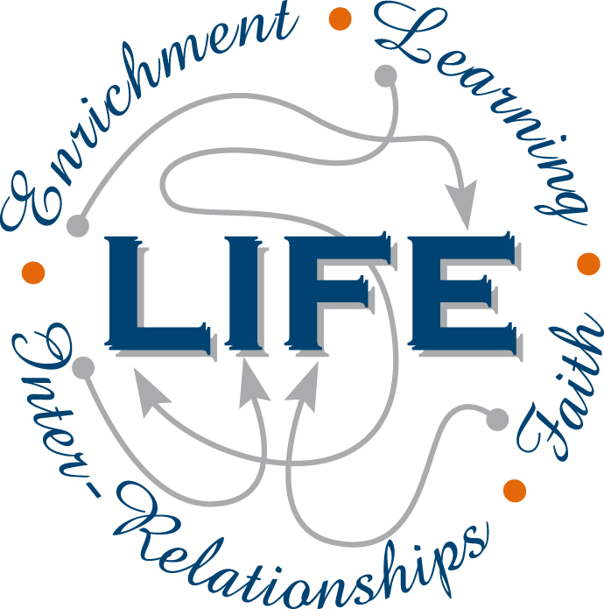
Holy Cross College

Semester 1 Examination 2012

Question/Answer Booklet

Year 10 Science
Please place your student identification label in this box
(General)

Student Name
Student’s Teacher

Time allowed for this paper

Reading time before commencing work: 10 minutes
Working time for paper: 90 minutes

Materials required/recommended for this paper

To be provided by the supervisor

This Question/Answer Booklet
Data Sheet

To be provided by the candidate

Standard items: pens, pencils, eraser, correction fluid, ruler, highlighters.
Special items: non-programmable calculators satisfying the conditions set by the School Curriculum and Standards Authority for this course.

Important note to candidates

No other items may be taken into the examination room. It is your responsibility to ensure that you do not have any unauthorised notes or other items of a non-personal nature in the examination room. If you have any unauthorised material with you, hand it to the supervisor before reading any further.

Structure of this paper

Section | Number of questions available | Number of questions to be answered | Suggested working time  (minutes) | Marks available | Percentage of exam
Section One:  Multiple Choice | 50 | 40 | 30 | 50 | 35
Section Two:  Short Answer | 14 | 14 | 45 | 84 | 58
Section Three:  Comprehension | 1 | 1 | 15 | 10 | 7
 |  |  |  | 144 | 100

Instructions to candidates

1. The rules for the conduct of examinations at Holy Cross College are detailed in the College
Examination Policy. Sitting this examination implies that you agree to abide by these rules.

2. Write your answers in this Question/Answer Booklet.

3. Working or reasoning should be clearly shown when calculating or estimating answers.

4. You must be careful to confine your responses to the specific questions asked and to follow
any instructions that are specific to a particular question.

5. Spare pages are included at the end of this booklet. They can be used for planning your
responses and/or as additional space if required to continue an answer.

• Planning: If you use the spare pages for planning, indicate this clearly at the top of the
page.
• Continuing an answer: If you need to use the space to continue an answer, indicate in
the original answer space where the answer is continued, i.e. give the page number.
Fill in the number of the question(s) that you are continuing to answer at the top of the
page.

Achievement Standards

The transmission of heritable characteristics from one generation to the next involves DNA and genes.

The atomic structure and properties of elements are used to organise them in the Periodic Table.
SECTION 1 MULTIPLE CHOICE (50 marks)

Choose the best answer for each question in the Multiple Choice Question booklet.

Mark your selection with a cross.

1 | (a) | (b) | (c) | (d) |  | 26 | (a) | (b) | (c) | (d)
2 | (a) | (b) | (c) | (d) |  | 27 | (a) | (b) | (c) | (d)
3 | (a) | (b) | (c) | (d) |  | 28 | (a) | (b) | (c) | (d)
4 | (a) | (b) | (c) | (d) |  | 29 | (a) | (b) | (c) | (d)
5 | (a) | (b) | (c) | (d) |  | 30 | (a) | (b) | (c) | (d)
6 | (a) | (b) | (c) | (d) |  | 31 | (a) | (b) | (c) | (d)
7 | (a) | (b) | (c) | (d) |  | 32 | (a) | (b) | (c) | (d)
8 | (a) | (b) | (c) | (d) |  | 33 | (a) | (b) | (c) | (d)
9 | (a) | (b) | (c) | (d) |  | 34 | (a) | (b) | (c) | (d)
10 | (a) | (b) | (c) | (d) |  | 35 | (a) | (b) | (c) | (d)
11 | (a) | (b) | (c) | (d) |  | 36 | (a) | (b) | (c) | (d)
12 | (a) | (b) | (c) | (d) |  | 37 | (a) | (b) | (c) | (d)
13 | (a) | (b) | (c) | (d) |  | 38 | (a) | (b) | (c) | (d)
14 | (a) | (b) | (c) | (d) |  | 39 | (a) | (b) | (c) | (d)
15 | (a) | (b) | (c) | (d) |  | 40 | (a) | (b) | (c) | (d)
16 | (a) | (b) | (c) | (d) |  | 41 | (a) | (b) | (c) | (d)
17 | (a) | (b) | (c) | (d) |  | 42 | (a) | (b) | (c) | (d)
18 | (a) | (b) | (c) | (d) |  | 43 | (a) | (b) | (c) | (d)
19 | (a) | (b) | (c) | (d) |  | 44 | (a) | (b) | (c) | (d)
20 | (a) | (b) | (c) | (d) |  | 45 | (a) | (b) | (c) | (d)
21 | (a) | (b) | (c) | (d) |  | 46 | (a) | (b) | (c) | (d)
22 | (a) | (b) | (c) | (d) |  | 47 | (a) | (b) | (c) | (d)
23 | (a) | (b) | (c) | (d) |  | 48 | (a) | (b) | (c) | (d)
24 | (a) | (b) | (c) | (d) |  | 49 | (a) | (b) | (c) | (d)
25 | (a) | (b) | (c) | (d) |  | 50 | (a) | (b) | (c) | (d)

SECTION 2 SHORT ANSWER (84 marks)

Attempt all questions. Write your answers in the spaces provided.

1. Write the correct number next to each definition.

1. Homozygous
DEFINITION | NUMBER
Part of the cell containing DNA.
Allele that is masked by another.
Unit of heredity.
Alternatives for a gene.
When there are 2 of the same allele for a particular gene.
There are 46 of these in a human cell.
The genes representing a characteristic.
The physical characteristic shown.
The allele that will mask another.
When there are 2 different alleles for a particular gene.
2. Heterozygous
3. Allele
4. Chromosome
5. Gene
6. Recessive
7. Dominant
8. Phenotype
9. Genotype
10. Nucleus

(5 marks)

2. Carefully examine the photo of a young animal (centre) showing the genetic condition called
albinism.

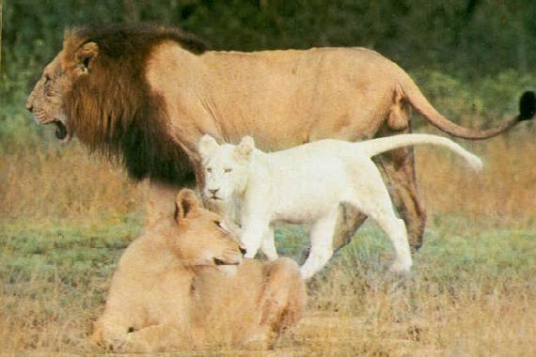

(a) Describe the phenotype of an animal with albinism.

(1 mark)

(b) The young lion cub inherits all its features from its parents. As you can see in the
picture, the lion cub shows the condition but neither of its parents (the male and female
lions in the picture) is albino.

Suggest two reasons that explain why the phenotype for albinism seen in the lion cub is
not visible in either of the lions parents.

(i)

(ii)

(2 marks)

3. Complete the table below labelling the parts of the following diagram of a generalised cell.
Include the function of each organelle.

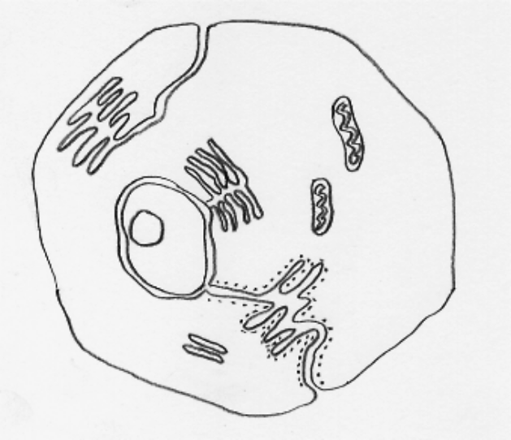
4. (small dots)
5.
3.
2.
1.
(5 marks)
NUMBER | ORGANELLE | FUNCTION
1
2
3
4
5
4. The chart below shows the inheritance of a rare (but not serious) blood disorder through four
generations of a family. Individuals with the condition are represented by the shapes that
have been shaded in.

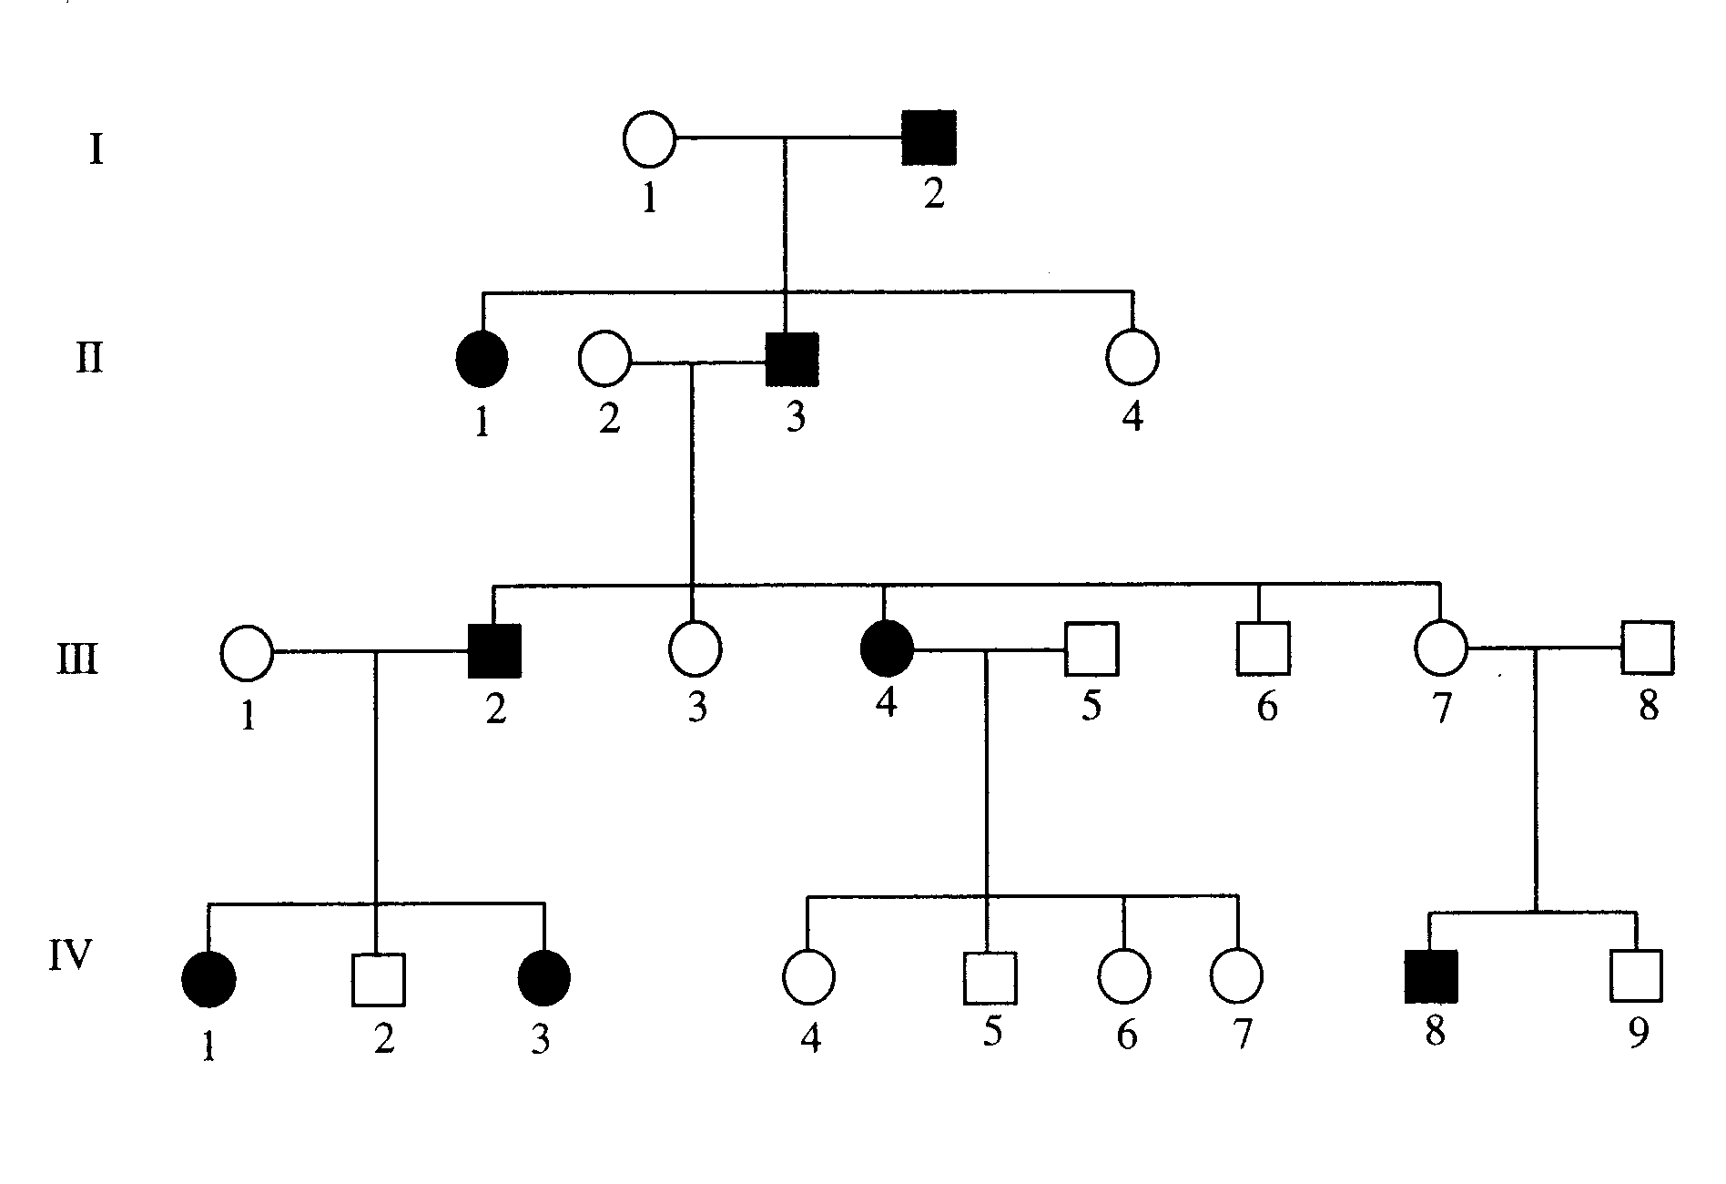

(a) How many people in total show the disorder in this family? (1 mark)

(b) How many of the people with the disorder are female?
(1 mark)

(c) How many children did person II 2 and II 3 have in total?
(1 mark)

(d) Do you think the gene that causes the disorder in this family is controlled by a dominant
gene or a recessive gene? Give one reason from the chart to explain your answer.
(You may need to circle the part used for your explanation.)

(2 marks)

(e) Assume the dominant gene for the disorder is D, and the recessive gene is d.

Give the genotype for the following individuals.

II 2 III 3 III 7 IV 8

(4 marks)
5. In guinea pigs, rough coat is dominant to smooth coat. Two hybrid rough coated
guinea pigs are mated. Determine the genotype and phenotype of the possible offspring.
Include percentages to show the probabilities. Show all of your working.

(4 marks)

6. In snapdragon flowers, red colour is incompletely dominant to white colour. Heterozygous
plants produce pink flowers.

(a) Describe the genotype and phenotype of possible flower colours if a pink snapdragon is
crossed with a white snapdragon. Include the ratios and show all of your working.

(4 marks)

(b) In some plants, flowers show co-dominance. For example, crossing a red flower with a
white flower produces red flowers with white parts, or vice versa. Explain how co-
dominance is different to incomplete dominance.

(2 marks)

7. Mitosis and meiosis are both types of cell division that occur in humans and other organisms.

(a) In the table below outline the differences between the two. Use humans as the
example.

 | Where does this process occur? | How many cells are produced? | How many chromosomes are there in each cell.
Meiosis

Mitosis

(3 marks)

The diagrams below show various stages of mitosis. They are in a jumbled order.

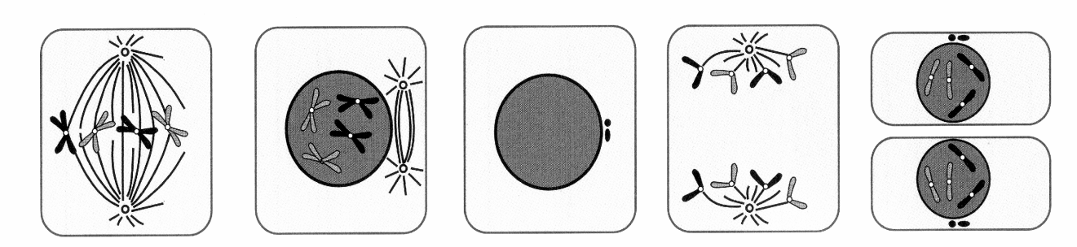

(b) Underneath each diagram write the correct name of the phase. (5 marks)

(c) Complete the below table by explaining the major events occurring in each phase.

STAGE | MAJOR EVENT

(5 marks)

8. (a) Who determines the sex of any children born into a family - the father or mother? Give
a reason for your answer.

(2 marks)
(b) A family has three girls born over five years and the mother is pregnant with a fourth
child. What is the chance of the unborn child being a female?

Justify your answer by setting out a genetics calculation using a Punnett square.

(4 marks)
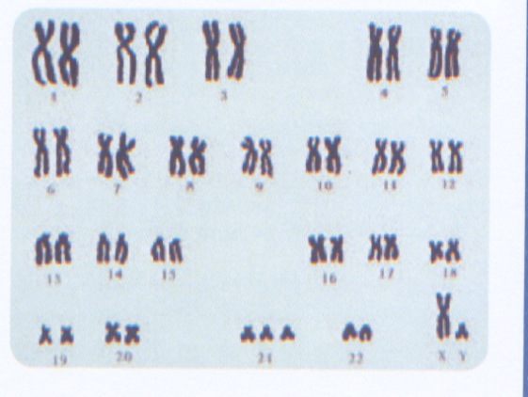
9. A newborn baby shows distinct facial abnormalities. A
karyotype was prepared to determine whether there were
any chromosomal abnormalities. The karyotype is shown
to the right.

(a) What is the total number of chromosomes shown?

(1 mark)

(b) Is the child male or female? How do you know?

(2 marks)

(c) As the geneticist, what would you advise the parents about the health of their baby?

(2 marks)
10. In the table below, choose the correct meaning for each word given. Write the letter of the
correct meaning next to the word.

WORD | CORRECT  LETTER | MEANINGS
neutron |  | A - a row of the periodic table.
period |  | B - building block of matter.
molecule |  | C - two or more elements chemically combined.
compound |  | D - two or more atoms chemically combined.
group |  | E - column of the periodic table.
atom |  | F - particle with no charge.

(3 marks)

11. Complete the following table, using the periodic table to assist.

Symbol | Number of Protons | Number of Neutrons | Number of Electrons
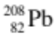
 | 53 | 72 | 53
 | 12 | 12 | 12
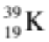

(4 marks)

12. (a) Draw the electron configuration diagrams for the following elements. Remember to
include the particles in the nucleus.

(i) 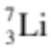 (ii) 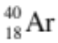

(iii) 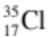 (iv) 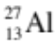

(8 marks)
(b) Explain how the electron configuration of an element determines its position in the
periodic table.

(2 mark)

13. Classify the following elements as alkali metals, transition metals, metalloid (semi-metals),
or halogens or noble (inert) gases.

Xe Te Cs Mn F Li I Ne Na Ni Ge Hg

Halogen | Noble (Inert) Gas | Alkali metal | Transition Metal | Metalloid  (Semi-Metal)
(6 marks)

14. Write the symbols or names for the following elements.

ELEMENT | SYMBOL
chlorine
potassium
gold
argon
manganese
 | Zn
 | Ca
 | W
 | Sn
 | B
(5 marks)
SECTION 3 COMPREHENSION (10 marks)

Read the article and then answer the questions that follow. Write your answers in the spaces provided.

Mutation

A mutation is a change in a gene or chromosome in a cell that can be passed on to daughter cells produced by mitosis or meiosis of this cell. Mutation is the process by which a gene (or chromosome) changes structurally and therefore the phenotype changes as a result. Without mutation and the alleles it produces, the biological diversity that exists today would not have evolved.

Mutations, put simply, are the permanent alterations in a cell’s DNA that affect the nucleotide sequence of one or more genes. They can be helpful or harmful to a species, but are usually harmful. The simplest is a point mutation, the change in a single nucleotide. Mutations are most likely to involve cells undergoing cell division. A single cell, a group of cells, or an entire individual may be affected. An entire individual may be affected if mutations occur during meiosis or early in development. For example, a mutation that affects a gamete will be inherited by a child of that individual.

The rate of gene mutation is low. However, as each individual has a large number of genes, mutations are constantly occurring within a species. The rate at which mutations occur can be increased through exposure to mutagens such as radiation, chemicals or temperatures above the normal range for the organism.

Variation and evolution

Mutation ultimately provides genetic diversity; this is the raw material of evolution. Mutation rates are usually very low and, even if different alleles mutate at different rates, this by itself will not lead to rapid changes in populations.

Why would a diploid organism take a random sample of its DNA and combine it with a random
sample of someone else’s DNA to produce offspring? The asexual way of life seems like an efficient way to reproduce yourself. What is the evolutionary benefit to organisms to develop sexual processes? Why is it better to combine the gametes of two individuals to produce a new generation of offspring?

Sexual reproduction allows for the provision of much more variation in organisms. Not only is just
half the genome of an individual passed on to every organism produced sexually, but that half is a random jumble, which may provide some advantage to the offspring. A sexual organism can achieve a significant amount of variation through recombination of DNA and fertilisation. In a changing environment a sexually reproducing organism increases the likelihood that it will adapt to changes that occur.

A haploid asexual organism accrues mutations as they occur over time in an individual. A sexually reproducing organism can combine several beneficial mutations in each generation by recombination and fertilisation. Therefore, sexually reproducing organisms can adapt at a much more rapid rate than asexually reproducing organisms.

Sexually reproducing organisms can eliminate harmful mutations each generation by either forming recombined offspring that are relatively free of mutation, or by producing offspring with many detrimental mutations that then die, removing the harmful mutations from the population.

1. What does the term "mutation" mean in genetics?

(2 marks)

2. What process has relied upon mutations to produce diversity and variation within a
population?

(1 mark)

3. When might a mutation affect an entire individual?

(2 marks)

4. How is the rate of mutations within the population increased?

(2 marks)

5. What provides genetic diversity within a population?

(1 mark)
6. Give two benefits of sexual reproduction within a population.

•

•

(2 marks)

END OF EXAMINATION

THIS PAGE HAS BEEN DELIBERATELY LEFT BLANK.

